Chapter 6, Solution 56.

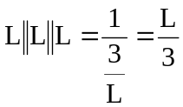
Hence the given circuit is equivalent to that shown below:
L
L
L/3
L/3

